**Emergency Vehicle Identification**

# **Introduction**

An emergency vehicle detection system can improve public safety by alerting drivers to the presence of emergency vehicles and helping them to clear a path. This can help to reduce response times and improve traffic flow, ultimately improving road safety.

One possible application of an emergency vehicle detection system is to integrate it into a vehicle's navigation system (Harish & Deepak, 2017). This could allow the system to automatically alert the driver to the presence of an emergency vehicle and provide instructions on how to safely move out of the way. The system could also be integrated into traffic management systems to help improve traffic flow and reduce congestion (Mittal et al., 2022). Additionally, the information gathered by the emergency vehicle detection system could be used by emergency responders to better understand and optimize response times and routes.

# **Methodologies**

**The Dataset**

The dataset set used consists of two categories, train and test, each of which consists of two categories as well, a csv file containing the image names and another column containing binary to indicate whether or not a vehicle is emergency (for the training set), and a subfolder containing images with their corresponding names in the csv file (for the test set). The dataset was made available for free on Kaggle.

**Data Analysis**

The training images consisted of 1646 JPG files and had records for each file in the csv file, whereas the test set was made up of 706 images and only had one column for image names and did not have all images accounted for in their respective csv file, thereby reducing the quantity of images that can be used for testing.

The target variable for training was imbalance in favor of not emergency vehicles.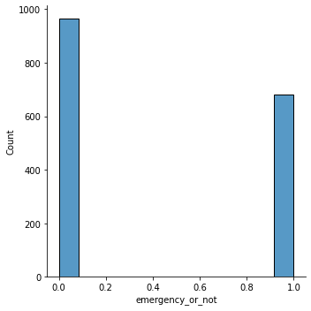

Figure 1 - Distribution of Emergency or not

**Feature Selection**

Given the nature of the data, which included both images and a csv file, it was critical to use a technique that could fuse both data sets together. To that end, the OS module and IO function from the Skimage libraries were used to read and join the two datasets while successfully using the pandas to list function to select X and Y variables. Following that, the variables were converted to numpy arrays and then split into training and validation sets in readiness for model development. This ensured that the model would have access to all of the necessary data to accurately learn and make predictions.

**Steps before model development**

* Identify the problem
* Collect and organize the data
* Preprocess the data to prepare it for use in the model
* Determine the type of neural network architecture
* Decide on number of layers and epochs

**Model Development**

The type of Neural Network used was determined by the image data. The convolutional neural network (CNN) was chosen with Conv2D architecture. This combination is great for processing data with a grid-like structure, such as an image. Conv2D layers can be used to learn spatial hierarchies of features from image data, allowing a CNN to identify and classify objects within an image (Geeks for geeks, 2022). This makes them useful for computer vision applications such as image classification and object detection such as this project.

In this phase, a sequential model was created, and several layers were added to it. The first four layers were convolutional layers using the Conv2D function, with the input shape specified for the first layer and ReLU activation functions for all four layers. These were followed by four max pooling layers using the MaxPooling2D function. Next, two dense layers were added using the Dense function, with ReLU activation functions and dropout layers in between. Finally, an output layer was added using the Dense function with a sigmoid activation function due to its distinctness between 0 and 1. The model was then compiled using the compile function and fit to the training data.

# **Results**

The model had an accuracy of 83%, which means that it was able to correctly predict the outcome 83% of the time. However, because the data was imbalanced, the model was better at predicting one class over the other.

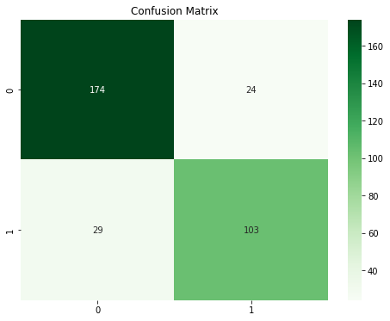

Figure 2 - Classification of labels

The confusion matrices indicate that 174 non-emergency images were correctly classified, but 24 were misclassified. Similarly, 103 emergency vehicles were correctly classified, but 29 were misclassified.

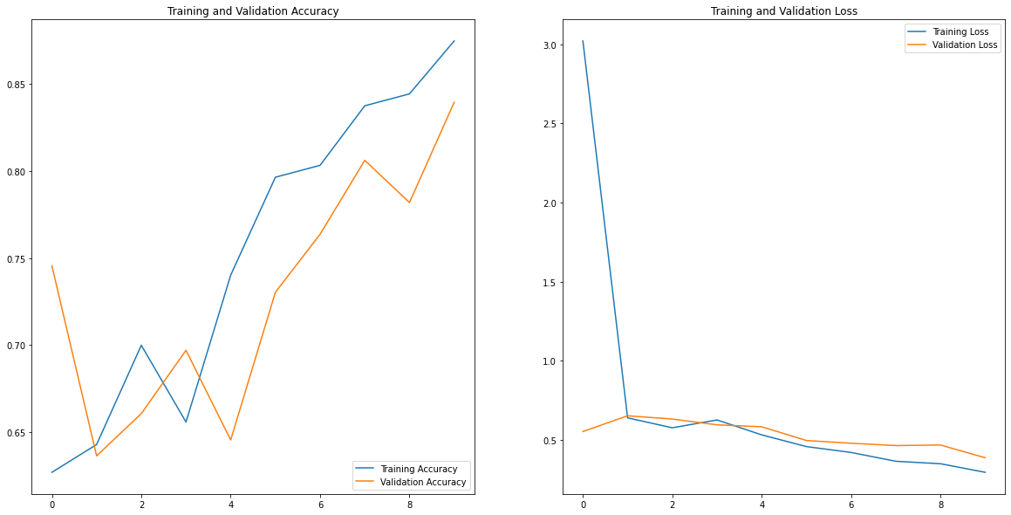

Figure 3 - Over epoch performance

During the training phase, the model initially had a low accuracy and high loss, which is expected at the beginning of training. As the number of epochs increased, the model was able to learn from the data and improve, resulting in higher accuracy and lower loss.

The prediction on the test set is shown below, and it confirms that the model is accurate 83% of the time. Three correctly identified non-emergency vehicles are shown, as well as one emergency vehicle that was classified as a non-emergency vehicle.

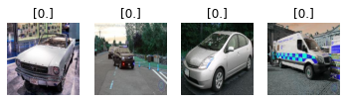

Figure 4 - Predicted classes

**Evaluation metrics importance**

For this task, I was more interested in the classification report, as it illustrates the misclassification level of the model. In comparison to accuracy, it is a great metric to show how accurate the model can classify labels.

**Effects of increased layers**

I observed that increasing the number of layers made the model perform poorly and took up more processing time. However, on adding a flattening layer before the output layer, the model's performance increased

**Conclusion**

Conclusively, the value of an emergency vehicle detection system cannot be overstated. A system like this can increase public safety by alerting drivers to the presence of emergency vehicles and assisting them in clearing a path. Overall, the system has the potential to significantly improve public safety and traffic flow.

The trained model can be deployed as it is or fine-tuned before deployment to make more accurate predictions.

The model neither overfitted nor underfitted. The training performance increased with time as the epochs increased.

# **References**

Geeks for geeks. (2022, August 24). *Keras.Conv2D Class*. GeeksforGeeks.

Available online: <https://www.geeksforgeeks.org/keras-conv2d-class/>

[Assessed 09/12/2022]

Harish, K., & Deepak, G. (2017, December). Accident Detection and Intelligent Navigation System for Emergency vehicles in Urban Areas using IoT. *International Journal of Engineering and Techniques*, *3*(6), 330 - 333.

[Assessed 28/11/2022]

Mittal, U., Chawla, P., & Kumar, A. (2022). Smart traffic light management system for heavy vehicles. In *Autonomous and Connected Heavy Vehicle Technology* (pp. 225-244).

Available online: <https://doi.org/10.1016/B978-0-323-90592-3.00013-6>

[Assessed 10/12/2022]

**Component 4**

**Ethical Challenges in Artificial Intelligence (AI) Systems**

**Introduction**

The ethical implications of AI are becoming increasingly important as the technology continues to advance. As AI systems become more sophisticated and are embedded into a number of aspects of human evolution, it is essential to consider the moral principles that should guide their development and use. There are ongoing calls for applied ethics amid the present AI boom to maximize the disruptive potential of the emerging technology (Hagendorff, 2020). It is important to ensure that AI systems are transparent and explainable, so that individuals can understand how they work and can hold them accountable. By considering these and other ethical issues, we can ensure that AI is used in a responsible and beneficial way. Some key ethical challenges of AI systems and potential solutions are discussed below

**Key Ethical Challenges**

1. **Surveillance and control:**

The increasing use of AI in surveillance systems, such as facial recognition and monitoring of social media, raises concerns about the potential for abuse and the intrusion of privacy and civil rights. Addressing this challenge will require the development of clear legal and ethical frameworks for the use of AI in surveillance, as well as mechanisms for holding those who misuse AI accountable. One of the key issues is the potential for AI systems to be used for invasive surveillance of individuals without their knowledge or consent. This could violate individuals' privacy and undermine their autonomy. Additionally, there are concerns about the potential for AI systems to be biased and discriminatory in their surveillance, leading to unequal treatment of certain groups. One example might involve the use of AI-powered cameras in public places to monitor criminal activity. In this case, the AI system would be trained to recognize certain behaviors or objects that are indicative of potential threats. Law enforcement agencies have been leading in the deployment of AI technologies such as facial recognition. However, it's crucial to acknowledge that this technology has invaded people's privacy (Almeida et al., 2022). To ensure that the use is ethical, the system would need to be designed and used in a way that minimizes the potential for invasions of privacy and discrimination.

1. **Lack of diversity and inclusivity in AI development:**

The field of AI is dominated by a narrow demographic of individuals, which can lead to a lack of diversity in the perspectives and experiences that are incorporated into AI systems. This can result in AI systems that are not inclusive or fair to all users. The systems can perpetuate and even amplify biases that are present in the data they are trained on, leading to unfair treatment of certain groups of people. For example, a facial recognition system that is trained on a predominantly white dataset may have difficulty recognizing people with darker skin tones, leading to potential false arrests. This challenge can be addressed through a combination of efforts, such as ensuring that datasets used to train AI systems are diverse and representative of the populations they will be used on, as well as regularly auditing and testing AI systems for biases.

1. **Lack of accountability:**

AI systems can be difficult to understand and interpret, making it challenging to hold them accountable for their actions. For instance, it may be challenging to hold an autonomous car accountable in the same way that a human driver would be. Addressing this challenge requires a combination of technical measures, such as creating explainable AI systems that can provide clear justifications for their decisions, as well as establishing clear ethical guidelines for the use of AI systems. This lack of accountability can also make it difficult to hold individuals or organizations accountable for any harm that is caused by an AI system. A properly functioning system checks all the boxes and allows no possibility for the AI to become errant and cause issues. (Swiss Cognitive, 2022).

1. **Unemployment and job displacement:**

The growing usage of AI in numerous industries may result in job displacement and unemployment. According to Frey and Osborne's (2013) estimation, machine learning (ML) and associated technologies have the potential to automate up to half of the US workforce's jobs. For instance, the application of AI in logistics and manufacturing may result in the automation of numerous jobs that were previously handled by people. Addressing this challenge will require a combination of efforts, such as providing support and training for workers who may be displaced by AI, as well as rethinking the role of work in society and considering the potential for universal basic income as a means of supporting those who are unable to find work

1. **Misuse and malicious use:**

AI systems can be misused or even intentionally designed for malicious purposes, such as hacking, fraud or developing autonomous weapons. Because AI systems can operate at a high speed and can process large amounts of data quickly, it can enable hackers and fraudsters to target a larger number of victims in a shorter amount of time, potentially causing widespread harm. For example, an AI-powered hacking tool could be used to access the personal information of thousands of people, putting them at risk for identity theft and other forms of financial fraud. Also, because AI systems can operate autonomously, it can be difficult to determine who is responsible for these actions. Addressing this challenge requires a combination of efforts, such as establishing clear regulations and legal frameworks that specifically address this misuse, as well as promoting research and development into technologies that can detect and prevent it. However, gaining understanding about how criminals can utilize AI will enhance the cybersecurity sector's and law enforcement agencies' capacity to foresee potential destructive and criminal behaviors and to prevent them (Europol, 2018).

**Conclusion**

In conclusion, the use of AI presents significant ethical challenges. It's important that users, AI systems developers, and governments collaborate to create laws, regulations, and procedures that support the ethical use of AI to address these issues. By doing so, we can help ensure that AI is used for the benefit of society and not for harmful purposes.

**Reference**

Almeida, D., Shmarko, K. & Lomas, E. (2022). The Ethics of Facial Recognition Technologies, Surveillance, And Accountability in an Age of Artificial Intelligence: A Comparative Analysis Of US, EU, And UK Regulatory Frameworks. AI Ethics 2, 377–387

Available online: <https://doi.org/10.1007/s43681-021-00077-w>

[Assessed 13/12/2022]

Europol (2018). Malicious uses and abuses of artificial intelligence.

Available online:<https://www.europol.europa.eu/cms/sites/default/files/documents/malicious_uses_and_abuses_of_artificial_intelligence_europol.pdf>

[Assessed 9/12/2022]

Frey, C.B. and Osborne, M. (2013). *The future of employment: How susceptible are jobs to computerisation*, Oxford Martin School working paper

Available online: <https://www.oxfordmartin.ox.ac.uk/downloads/academic/The_Future_of_Employment.pdf>

[Assessed 9/12/2022]

Hagendorff, T. (2020) The Ethics of AI Ethics: *An Evaluation of Guidelines. Minds & Machines* 30, 99–120 Available online: <https://doi.org/10.1007/s11023-020-09517-8>

[Assessed 14/12/2022]

Swiss Cognitive. (2022). Accountability is Essential for Ethical AI.

Available online:

<https://swisscognitive.ch/2022/06/16/accountability-is-essential-for-ethical-ai/>

[Assessed 14/12/2022]